YERING PRIMARY SCHOOL No. 1034  22-24 Melba Highway, (P.O.Box 139, Coldstream. 3770.)  Yering. VIC. 3770  ABN: 42 062 757 712  Phone: (03) 9739-1451 Email: yering.ps@edumail.vic.gov.au  Principal: Deanna Cole Website: www.yeringps.vic.edu.au | 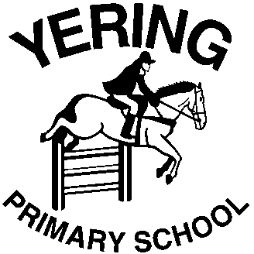
 | Small School Big Learning
17th June 2019

Dear Parents,

On Wednesday 26th June Yering Primary School staff and students are heading to Melbourne for a whole day excursion to coincide with our History Integrated Studies unit of work . We will be going to St Paul’s Cathedral to learn about the history of the building and check out the architecture, then it’s off to the Immigration Museum for a staff led experience ‘Our Stories’ and we will then head to Federation Square to see the ‘Top Arts’ Australian Art Collection at NGV.
Students will need to bring their own lunch, snacks and a water bottle.
Students need to be in full school uniform and dressed appropriately for the weather conditions of the day.

Excursion Details:

Date: Wednesday 26th June 2019
Time: Students will meet at Lilydale Railway Station, arriving by 8.20am. The train will depart at 8.35am. We will visit the following places: St Paul’s Cathedral tour 9.45am-10.30am, Immigration Museum program 11am-12.30pm and NGV at Federation Square. We will board the 2.30pm train from Flinders Street Station, arriving back at Lilydale Station at 3.33pm.
Cost: $8 per student

Yering staff

-----------------------------------------------------------------------------------------------------------------------------------------------------------------

PERMISSION FORM – Immigration Museum Excursion
Wednesday 26th June 2019

SURNAME_____________________________ EMERGENCY PHONE NO.__________________

I ____________________ _______hereby give permission for my child/ren____________________________

to participate in the Immigration Museum Excursion on Wednesday 26th June 2019.
I authorise the teacher in charge to consent, where it is impracticable to communicate with me, to my child/ren receiving such medical or surgical treatment as may be deemed necessary.

SIGNED:____________________________ DATED: ______________________

I enclose $_______ for my child/children OR

Please use funds from:

CSEF funds

School account

